Why Java is called as platform independent?

When you convert or process of converting the source code (Java code) into byte code, that byte code can run on any platform (machine) directly. It means that byte code (.class file) is platform independent.

How java program works?

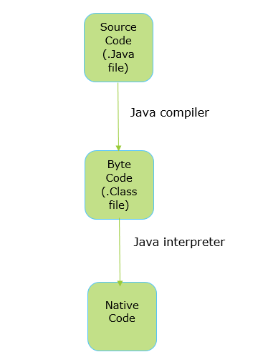

**Fig. Program execution flow**

This diagram will show you in-detailed description.

-Java compiler will check syntax errors.

-Java interpreter will convert byte code into native code.

-After converting into native code or machine code, we will able to see the output into the console.

Java Compiler

The process of converting entire source code into byte code with help of JVM that process is known as java compiler.

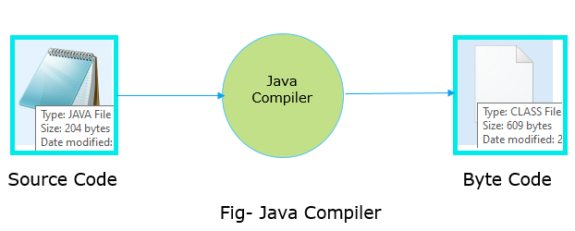

It is the program that contains set of instruction which is implemented in C or C++ programming languages.

**Purpose-**

It will just check your syntax errors or grammatical mistakes.

It is responsible for calling the constructor.

Java Interpreter

The process of converting byte code into native code that process is known as java interpreter.

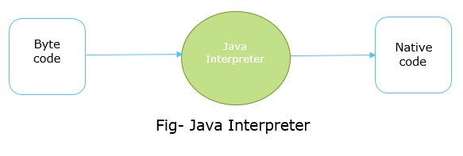

**It is nothing but .exe file which is implemented in C or C++ programming languages.**

JIT Compiler (Just In Time)

The process of converting byte code into machine code only once known as JIT compiler. It has more information like which classes has been loaded, which code is executed frequently, elimination of method calls, etc.